TRAINING AND PALCEMENT CELL

A Dissertation Report Submitted to
Rajiv Gandhi Prouduogiki Vishva Vidhyalaya, Bhopal.
Towards Partial Fulfillment for the Award of
Bachelor of Engineering (Computer Science & Engineering)
2010-2011



Supervised by: Submitted by:
Mrs. Varsha Zokarkar Sheetal Choudhary
Shruti Makode
Yashasvi Hegde

Department of Computer Science and Engineering
KCB Technical Academy, Indore
(www.kcbta.ac.in)
May 2011

Certificate

The dissertation entitled “TRAINING AND PLACEMENT CELL” submitted by Name of Student is approved as partial fulfillment for the award of the Bachelor of Engineering (Computer Science & Engineering) degree by Rajiv Gandhi Prouduogiki Vishva Vidhyalaya, Bhopal.

Internal Examiner External Examiner

Date: Date:

Director

KCB Technical Academy, Indore

Recommendation

The dissertation entitled “TRAINING AND PALCEMENT CELL” Submitted by Name of Student is a satisfactory account of the bona fide work done under our supervision is recommended towards partial fulfillment for the award of the Bachelor of Engineering (Computer Science & Engineering) degree by Rajiv Gandhi Prouduogiki Vishva Vidhyalaya, Bhopal.

Date:

Name of Guide Endorsed By Head
Mrs.Varsha Zokarkar

Department of Computer Science & Engineering
KCB Technical Academy, Indore

Acknowledgement

We acknowledge our sincere thanks to those who have contributed significantly to this project. It is a pleasure to extend the deep gratitude to our internal guide Mrs.Varsha Zokarkar, K.C.B.Technical Academy, for her valuable guidance and support to continuously promote us for the progress of the project. We thank her for valuable suggestions towards our project,which helped us in making this project more efficient and user friendly.

We thank each and every ones efforts who helped us in some or the other way for small and significant things.

Sheetal Choudhary(0834CS081094)

Shruti Makode(0834CS081099)

Yashasvi Hegde(0834CS081118)

Abstract

Training & Placement Portal aims at providing the Facility to automate and simplify the process of registration and list generation of eligible students for placement. This System provide facility to TPO to do all their Work Regarding Placement like Collecting Student Records, Registering the Suitable Students, to check the number and percentage of placed & unplaced students, and important announcements to other departments. The whole work is automated as well as on intranet.

Table of Contents

Certificate……………………………... …………….. I

Recommendation ………………………………………………………..… II

Acknowledgements …………………………………………………………. III

Abstract …………………………………………… … IV

Table Of Contents ……………………………………………………………V

- Introduction…………………………………………………
1.1 Purpose
1.2 Problem Statement
1.3 Project Objective
1.4 Scope and Limitations
  - Report Organization

2 Fundamental……………………………………………………
2.1 About the Platform
2.2 Common Features
2.3 Minimum System Requirements

3 Process Model Adopted ………………………………………
3.1 Analysis
3.1.1Requirement Analysis
3.1.2Object Oriented Analysis
3.1.3Architectural Specification

3.2 Design with Input & Output Artifacts
    - Use Case Diagram
    - Use Case Specification
    - Sequence Diagram
    - Class Design
    - Data Model

  - Implementation and Testing
3.3.1 Implementation Strategy
3.3.2 Front End Implementation
3.3.3 Back End Implementation
3.3.4 Screen Shots
3.3.5 Testing Strategy Adopted
3.3.6 System Testing
3.3.7 Component Testing

4.Conclusion………………………………………………………
4.1 Bibliography
4.2 Future Extensions

INTRODUCTION

INTRODUCTION

  - PURPOSE:

Computer based information system are designed to improve existing system. Whatever the information, TPO has to pass to the student and he or she can inform online. Improve accuracy in result. It has user friendly interface having quick authenticated access to documents. It provides the facility of maintaining the details of the students. It will reduce the paper work and utilize the maximum capabilities of the Setup and organization as well as it will save time and money which are spending in making reports and collecting data. It can be accessed throughout the organization and outside as well with proper login provided. This system can be used as an application for college to manage the student information with regards to placement.

  - PROBLEM STATEMENT:

Now a days, Student joins the college for the placement as well as for better training for their future. But there is manual training has going on there might be lot of problem student as well as placement manager has to face. All the transactions are done manually. Fake entries can be there. System is more error - prone & time consuming. Difficulty in managing data of students. Large piles of records are to be maintained. TPO’s have to collect the information of various companies who want to recruit students and notify students time to time about them. It is a time consuming activity of managing , updating and informing specific student for specific company requirements.

  - PROJECT OBJECTIVE

In order to avoid above existing problem we are design existing system as online Training and Placement system, so that whatever the information, TPO has to pass to the student and he or she can inform online. All the resume send by the student which can be maintain in the database . It reduce the paper work and storage area. Save time & work load for TPC Staff and students. Easy to access. Avoid fake Entry. Only Eligible students get chance. Improve accuracy in result. It has user friendly interface having quick authenticated access to documents.

  - SCOPE AND LIMITATIONS:

Project has a big scope to do. We Students can maintain their information and can update it. Notifications are sent to students about the companies. Students can access previous information about placement. This system has scope of improvement / amendments. In future, sector can communicate with each other online. All currently active enquires can also be added in the website to view if online. This application can be modified from time to time as per the changing requirement of the user with lesser cost also the backend of the application can be changed as per the storage requirement of the application and to provide more security level features. The limitation with the application can also be looked into and enhancement can be made as per user requirement .

All though this project is made only for a particular institute and supports a particular operating system platform , the wide application area of the project surpasses this small drawback. Hence proving its worth.

  - REPORT ORGANIZATION:

The purpose of this document is to present a final report of our project “Training And Placement Cell”. This document is divided into various sections. Section one provides the description of software used, problem encountered and its significance. Section two contains the details of our used platform in which the project is been made, its characteristics and requirement features. Section three contains literature survey which is the documentation of the published and unpublished work from secondary sources and give the details about the process model which is adopted and it also contains several sub-sections such as analysis, requirement analysis which includes functional as well as non functional requirements and then architectural specification and design. Class diagram contains class diagram which shows the classes of the system and their inter relationship. And then there is pictorial representation of GUI i.e. snapshot. Section four provides concluding remarks. Section four is a list of difficult technical or foreign term with definitions or abbreviations. This section also includes the references from where the information is collected.

2 FUNDAMENTALS

2.1 ABOUT THE PLATFORM:

Microsoft Visual Studio is an integrated development environment (IDE) from Microsoft. It can be used to develop console and graphical user interface applications along with Windows Forms applications, web sites, web applications, and web services in both native code together with managed code for all platforms supported by Microsoft Windows, Windows Mobile, Windows CE,.NET Framework, .NET Compact Framework and Microsoft Silverlight. Visual Basic 9.0 was released together with the Microsoft .NET Framework 3.5 on 19 November 2007. ASP.NET is a set of Web development tools offered by Microsoft. Programs like Visual Studio .NET and Visual Web Developer allow Web developers to create dynamic websites using a visual interface. ASP.NET also supports Visual Basic .NET, Jscript. .NET and open-source languages like Python and Perl. .NET provide a visual interface for developers to create their applications, which makes .NET a reasonable choice for designing Web-based interfaces as well.
SQL Server is a relational database developed and sold by Microsoft. Originally bought from Sybase, Microsoft have released versions 6, 6.5, 7, 2000 and 2005. The Express Edition of SQL Server 2005 is used in the C++ and C# .

2.2 COMMON FEATURES:

Microsoft added many features including:

1: Debugging the .NET source code
VS2008 has integrated debugging support so that you can step into the framework libraries. Visual Studio will automatically download the source file from Microsoft’s server and you will get full watch and breakpoint support.

2: Visual Studio Split View
It is becoming increasingly more common to have multiple monitors on developers desks. Building on the “split” window feature of VS 2005, Visual Studio 2008 now allows you to tile the window horizontally or vertically so you can split your design and code view across monitors

3: C# 3.0 support
Things like automatic properties, lambda expressions (which reduce your typing for anonymous delegates), partial methods, anonymous types and extension methods will radically change how you can build applications. They will cut down your typing and provide for some really cool ways to enhance and evolve your projects.

4: Refactoring enhancements
The refactoring support was a welcome addition to VS 2005 - and Microsoft has enhanced the support in 2008 to support C# 3.0 features and allow you to refactor anonymous types, extension methods and lambda expressions.

5: Organize your "using" statements
Visual Studio now has the ability to organize your using statements. As a project evolves, you often end up with a ton of using statements at the top of each file which are not really being used - either because the project template added it, or because you originally did use something from that namespace which was then removed later. Now you can right click on your using statements and sort and/or remove unused namespaces.

6: Better Intellisense support
Visual Studio now has intellisense and code completion support! It’s smart enough to look at the underlying type currently assigned and correctly infer the methods which are available..
Visual Studio will also look at the comments applied to your methods - just like in C# and VB.NET, it will pull descriptions out of XML based comments on your JavaScript methods and display descriptions as tooltips when you are navigating the intellisen se dropdown.
Now if you press a letter and start typing, it will begin to restrict your choices displayed, not just scroll to that section. This filters the output and makes it easier to find what you are looking for.

7: Multi-framework targeting
This release of Visual Studio has a much-needed feature that I wish had been there before - the ability to target multiple versions of .NET. Specifically, you can select your target framework (2.0 SP1, 3.0 or 3.5) and the project types, toolbox, references, intellisense and features will be appropriately set to that version. This selection can occur during project creation - in the project templates dialog or on the project properties dialog. Be aware that selecting .NET Framework 2.0 actually means 2.0 SP1 and not the original .NET 2.0 framework released with Visual Studio 2005.

2.3 MINIMUM SYSTEM REQUIREMENTS:

Technology | Dot Net
Front end | ASP Dot NET with C#
Back end | Microsoft SQL Server
Operating system | Windows XP
RAM | 256 Mb
Hard disk | 2gb
Processor | Intel Pentium core 2duo
Keyboard | HCL
Monitor | HCL
Mouse | HCL

3 PROCESS MODEL ADOPTED:

Here, we are using SPIRAL MODEL.
The spiral model is a software development process combining elements of both design and prototyping - in - stages, in an effort to combine advantages of top -down and bottom-up concepts. Also known as the spiral lifecycle model (or spiral development), it is a systems development method (SDM). This model of development combines the features of the prototyping model and the waterfall model. A first prototype of the new system is constructed from the preliminary design. This is usually a scaled-down system, and represents an approximation of the characteristics of the final product.

A second prototype is evolved by a fourfold procedure:
- Evaluating the first prototype in terms of its strengths, weaknesses, and risks.
- Defining the requirements of the second prototype.
- Planning and designing the second prototype.
- Constructing and testing the second prototype.

Strengths:
  - Introduces risk management.
  - Prototyping controls costs.
  - Evolutionary development.
  - Release builds for beta testing.
  - Management Advantages.
Applications

For a typical shrink-wrap application, the spiral model might mean that you have
a rough-cut of user elements (without the polished / pretty graphics) as an operable
application, add features in phases, and, at some point, add the final graphics.
The spiral model is used most often in large projects. For smaller projects, the
concept of agile software development is becoming a viable alternative. The US military
has adopted the spiral model for its Future Combat Systems program.

Advantages

- Estimates (i.e. budget, schedule, etc.) get more realistic as work progresses , because important issues are discovered earlier.
- It is more able to cope with the (nearly inevitable) changes that software development generally entails.
- Software engineers (who can get restless with protracted design processes) can get their hands in and start working on a project earlier.

3.1 ANALYSIS:

Study and analysis
QUESTIONNAIRS

Questionnaire is done to know:
- Problems encountered by the management while managing the manual details of the students.
- The process for maintaining the master database of the students and calculating their respective percentages.
- Difficulty faced during sorting the students according to eligibility criteria.
- Problem occurred in any type of updation.

INTERVIEW

Interview is done to know the following:
- Understand the process of maintaining details of students.
- Understand the mechanism of sorting the students on basis of eligibility criteria.
- How database is maintained and stored?
- How students are made to know about the arriving companies and their criteria.
- How the records are updated in case of changes occur.

3.1.1 REQUIREMENT ANALYSIS:
Q1. Which technology is used?
Ans. DotNet.

Q2. Which Front End is used?
Ans. ASP.Net with C#.

Q3. Which Back End is used?
Ans. Microsoft SQL Server 2005.

Q4. Which Operating System is used?
Ans. Windows XP.

Q5. How much Hard disk will require?
Ans. Up to 2gb.

Q6. How much RAM will require?
Ans. Minimum 256mb.

Q7. What are the works that management does when recruitment work is done?
Ans. Collecting the data of students regarding their personal detail, academic details etc.

Q8. What among these works are done manually?
Ans. Students personal details are already written in the database, but the academic details keeps on changing hence the work of sorting the students is done manually.

Q9. Is the work too tedious?
Ans. Yes, it is quite a bit time taking.

Q10. How much time is required in sorting listing and updating?
Ans. Depends on the company criteria. If a particular company has more criteria than just the aggregate of student then it takes more time to sort students likewise.

Q11. Is the details maintained prior the company comes for recruitment or is done when company comes?
Ans. Some of them like maintaining the academic records, achievements of students etc are done before but the work like sorting is done when company comes according to their criteria’s.

Q12. What are the major problems faced while working?
Ans. Not much problem is faced but yes it is time taking and requires a huge pile work and requires more employees, paper work etc.

Q13. In our project Training and Placement cell what all main aspect do you need?
Ans. Starting from the data accumulation to final sorting, the project should include everything. It should take less time and should not need more employees to work at, user friendly so that everyone can use.

Q14. What is the procedure followed from start in the existing system?
Ans. 1. Collecting student’s records.
2. Updating as and when required.
3. Academic records maintaining when results come.
4. Companies recruitment details to be given to students.
5. Sorting students accordingly

Q15. Is the list of placed and unplaced students given at the end of the recruitment procedure?
Ans. Yes, but it is hand typed and displayed on the notice board.

Q16. Do you want the cell to be online?
Ans. Yes.

Q17. Even students should be able to view and update their information.
Ans. Yes, this facility can be employed.

Q18. Do you maintain any type of backup records?
Ans. Yes, but about the placed unplaced students.

Q19. Which area is most difficult to maintain?
Ans. Every area is equally managing but fake entries tend to occur.

Q20. On which platform do you need the software to be made?
Ans. Any would do but should be efficient enough.

Q21. Can each student have their own login id or it should be public.
Ans. Yes, it can be there.

Q22. Recruiting companies’ details can be specified to each student and for every user?
Ans. Yes.

Q23. Which user can do login?
Ans. Only TPO of the college and registered students.

Q24. How data is manage in proposed system?
Ans. Using tables with proper integrity constraint in the Database.

Q25. Which input is given?
Ans. Input design link between the information system and user.

Q26. Which output is expected?
Ans. Output is in the form of report.

Q27. Which type of report is generated?
Ans. The report is the document that contains information about document contains what type of matter.

Q28. How many reports are generated?
Ans. Basically two: 1).User report.
2). System report.

Q29. Is there any possibility to change the password?
Ans. Yes.

Q30. What is the main objective of this project?
Ans. The main objective of the system design is to make the system user friendly.

3.1.2 OBJECT ORIENTED ANALYSIS

Object-oriented analysis and design (OOAD) is a software engineering approach that models a system as a group of interacting objects. Each object represents some entity of interest in the system being modeled, and is characterised by its class, its state (data elements), and its behavior. Various models can be created to show the static structure, dynamic behavior, and run-time deployment of these collaborating objects. There are a number of different notations for representing these models, such as the Unified Modeling Language (UML).
Object-oriented analysis (OOA) applies object-modelling techniques to analyze the functional requirements for a system. Object-oriented design (OOD) elaborates the analysis models to produce implementation specifications. OOA focuses on what the system does, OOD on how the system does it.
An object-oriented system is composed of objects. The behavior of the system results from the collaboration of those objects. Collaboration between objects involves them sending messages to each other. Sending a message differs from calling a function in that when a target object receives a message, it itself decides what function to carry out to service that message. The same message may be implemented by many different functions, the one selected depending on the state of the target object.
The implementation of "message sending" varies depending on the architecture of the system being modeled, and the location of the objects being communicated with.

3.1.3 ARCHITECTURAL SPECIFICATION:

Three tier architecture:
Three tier architecture, also referred to as multi tier architecture as the middle tier may consists of several tiers by itself, emerged in 1990’s to overcome the limitations of the two tier architecture.

The third tier architecture is between the user and the interface run on client and the database management system run on the server. This middle tier provides process management where business logic and rules are executed and can accommodate hundreds of usres, as compared to two tiered architecture.

This architecture is the evolution of two tier applications. Logically the application is divided into three constituent layers:

User services:
Presentation layer: provides services such as the graphical user interface and other automation task that the application ahs to perform.

Business services:
Business layer: implements business rules. This layer encapsulates the business logic from user such that they need not know how business logic is applied. When project is upgraded only the business layer is affected and must be upgraded, the rest of application services can remain untouched.

Data services:
Data layer: provides data availability and integrity. It is responsible for adding modifying and deleting data from database.

The middle tier is basically application code, which a user invokes via the presentation layer to validate/insert/update/delete and retrieve business data from viewing. The presentation layer then receives the data and formats it for display. The separation of application logic from the user interface adds enormous flexibility to the design of an application.

The thid tier contains the business data required by the application. This business data can be held within an enterprise database such as ORACLE or MYSQL or a set of XML documents i.e. data that has been stored in a well formed document conforming to XML specifications.

3.2 DESIGN WITH INPUT AND OUTPUT ARTIFACTS

3.2.1 USE CASE DIAGRAM:

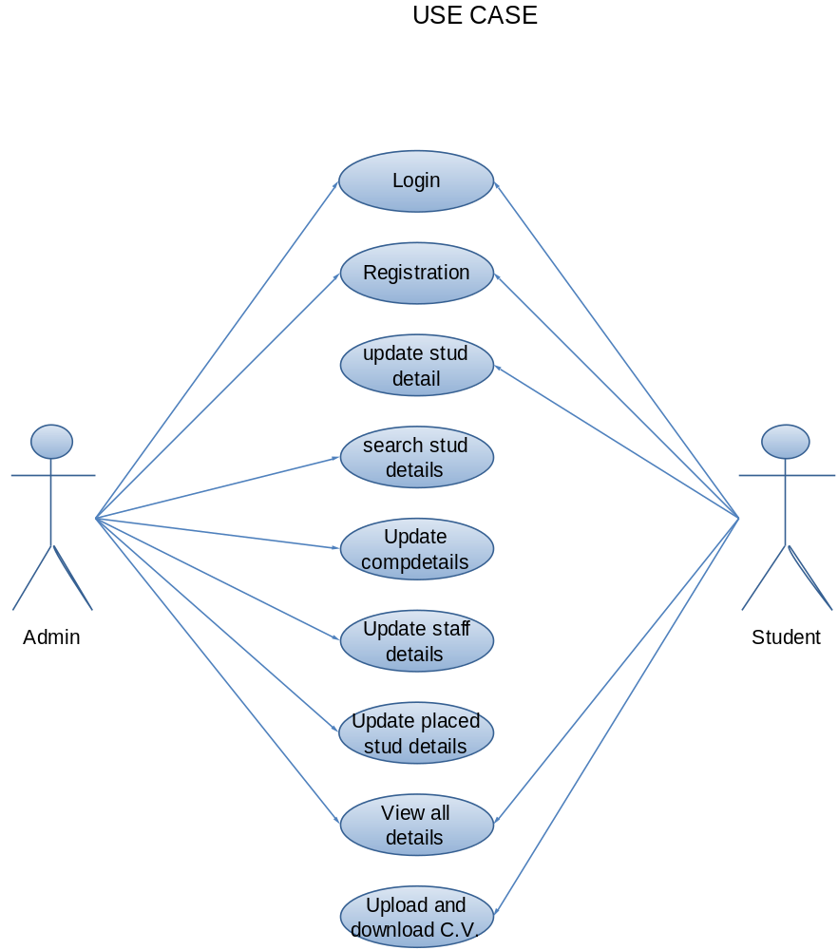

3.2.2 USE CASE DIGRAM SPECIFICATION:

Work in the application will be done in the following way:
- Access / Search information from the first page (only read access).
- The front-page of the system is created giving a brief description about the system and a login box .
- Login to the system through the first page of the application.
- See / change his / her details.
- Get help about the application on how to use the different features of the system.
- An admin login should be present who can read as well as remove any uploads. Preferably it should be given to the TPO.

3.2.4 SEQUENCE DIAGRAM

LOGIN

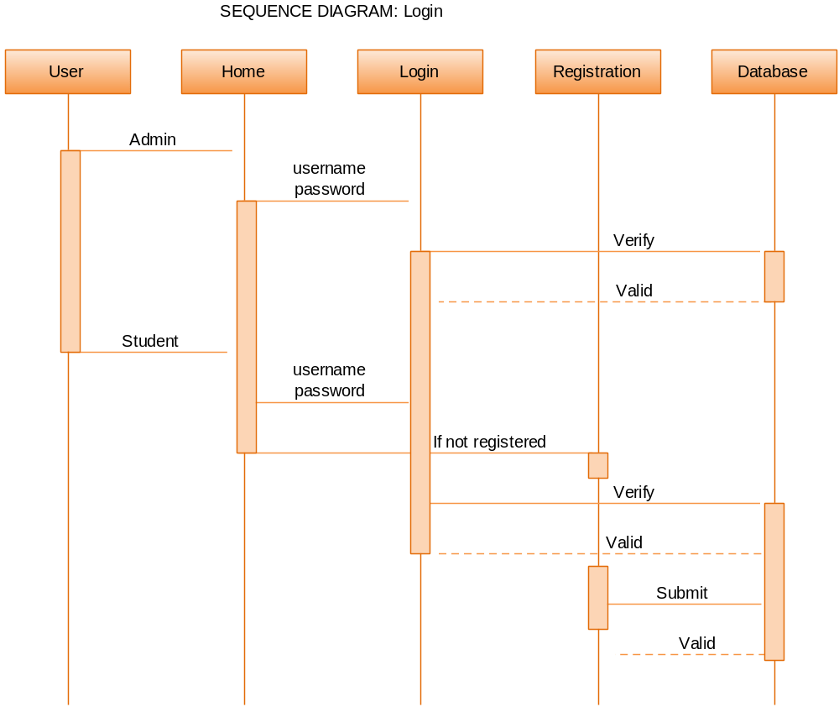

STUDENT

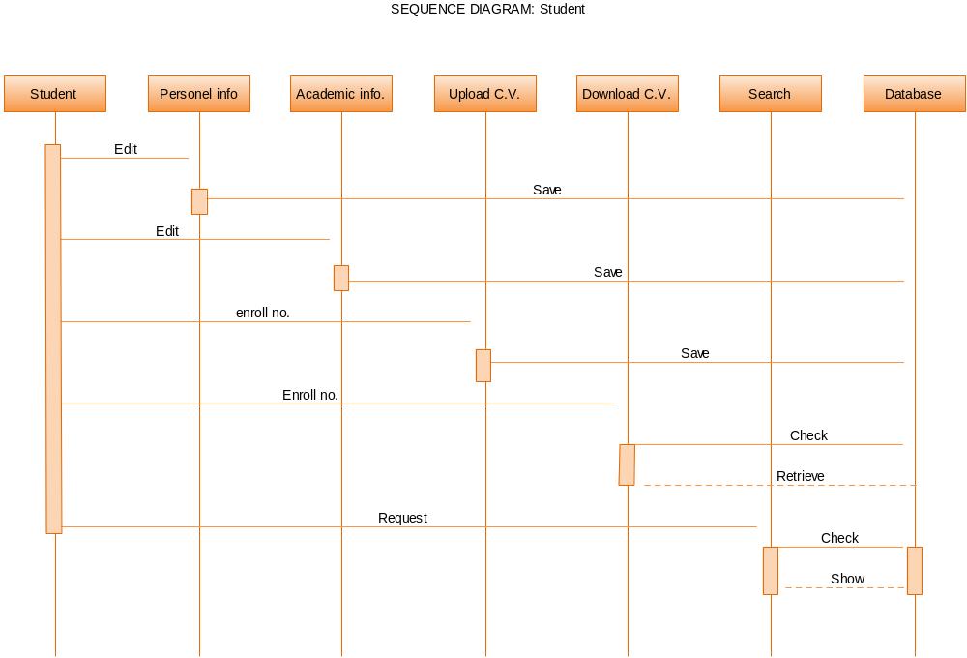

ADMIN

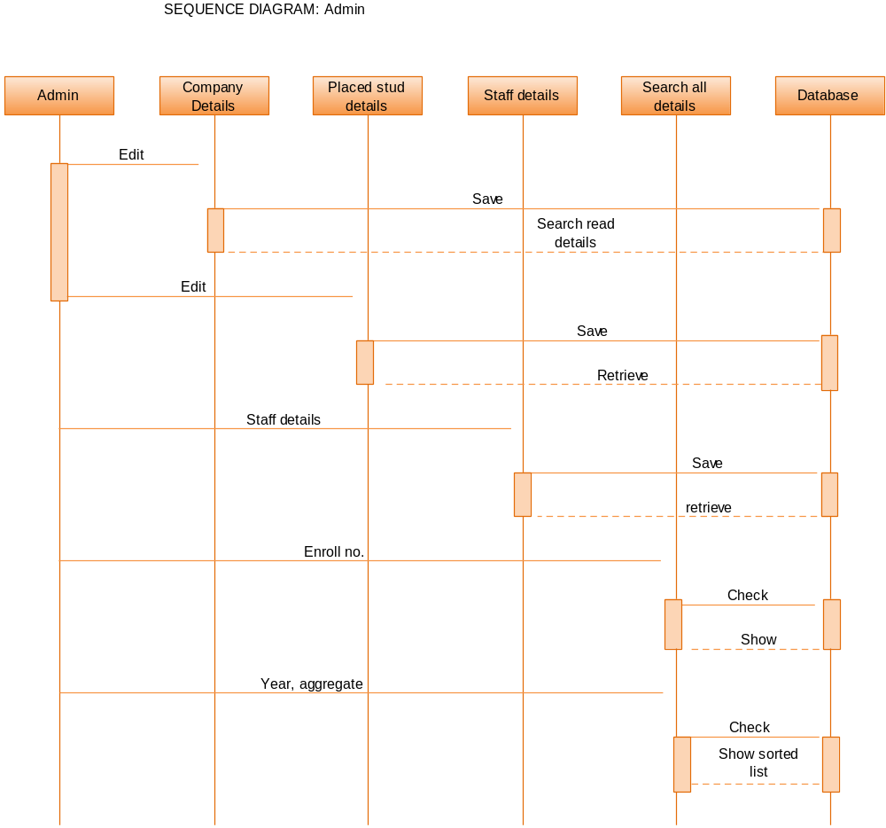

    - CLASS DIAGRAM

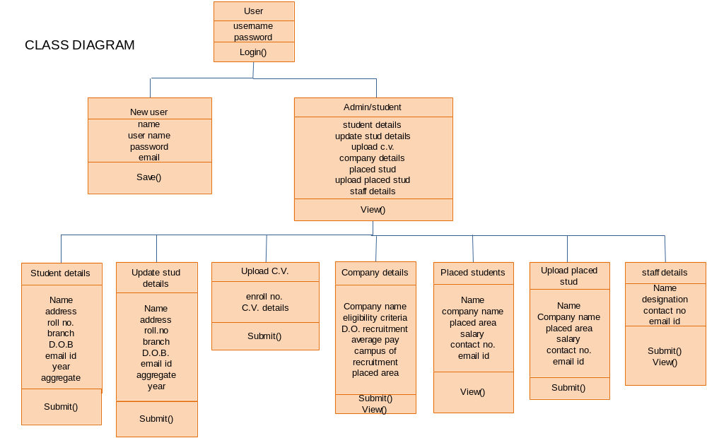

    - DATA MODEL:

DFD LEVEL 0

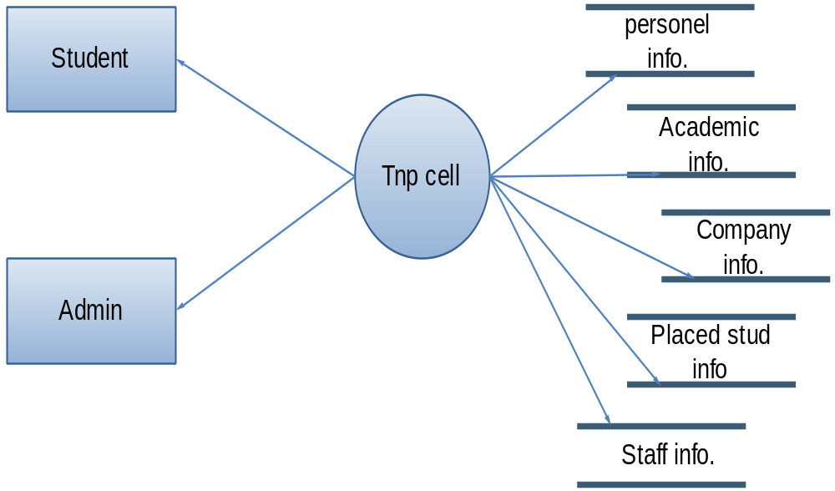

DFD LEVEL 1

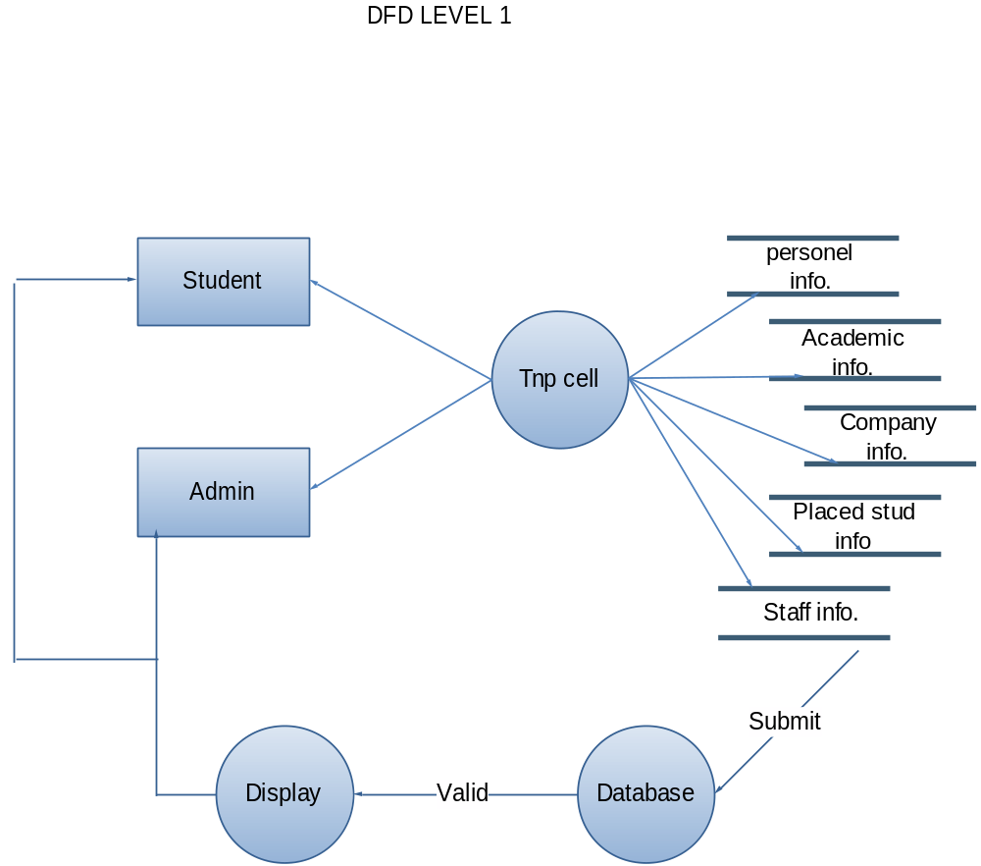

DFD LEVEL 2

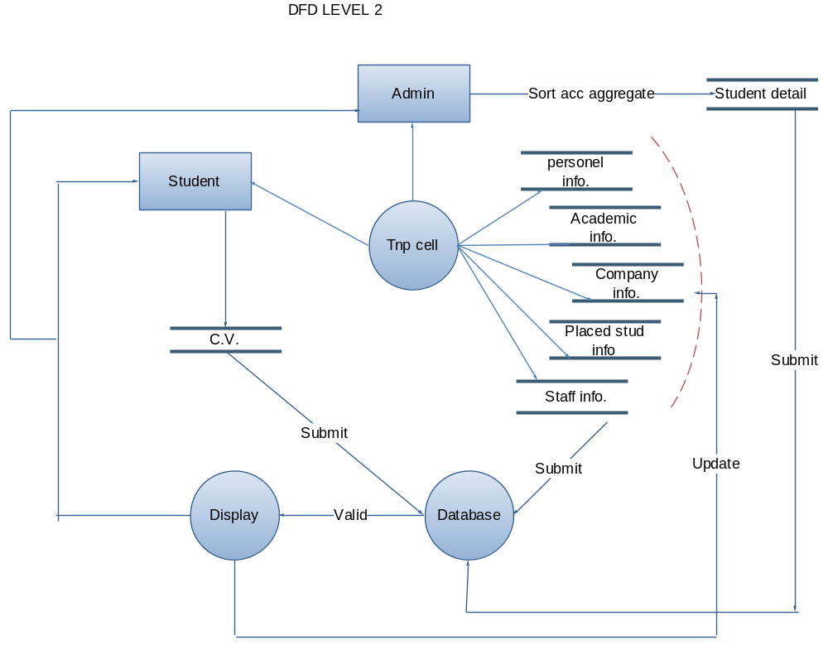

3.3 IMPLEMENTATION AND TESTING

    - IMPLEMENTATION STRATEGY:

Front End Implementation:

1). Login Page.

using System;
using System.Collections;
using System.Configuration;
using System.Data;
using System.Drawing;
using System.Linq;
using System.Web;
using System.Web.Security;
using System.Web.UI;
using System.Web.UI.HtmlControls;
using System.Web.UI.WebControls;
using System.Web.UI.WebControls.WebParts;
using System.Xml.Linq;
using System.Data.SqlClient;
public partial class LGN : System.Web.UI.Page
{
SqlConnection con;
SqlCommand cmd;
protected void Page_Load(object sender, EventArgs e)
{
if (Request.QueryString["rid"] == "1")
{
lblreg.Text = "you are successfully registered\n now you can Login Here ";
lblreg.ForeColor = Color.Blue;
}
if (Request.QueryString["rid"] == "2")
{
lblreg.Text = "Without login you cannot access student detail page ";
lblreg.ForeColor = Color.Red;
}
if (Request.QueryString["rid"] == "3")
{
lblreg.Text = "Without login you cannot access any page ";
lblreg.ForeColor = Color.Red;
}
if (Request.QueryString["rid"] == "4")
{
lblreg.Text = "Without login you cannot access any admin page ";
lblreg.ForeColor = Color.Red;
}
con = new SqlConnection(ConfigurationManager.ConnectionStrings["TNPConnectionString"].ToString());
con.Open();
}

protected void Button2_Click(object sender, EventArgs e)
{
Response.Redirect("StudRegist.aspx");
}
protected void Button1_Click1(object sender, EventArgs e)
{
try
{
if (txtunam.Text != "" && txtpass.Text != "")
{
cmd = new SqlCommand("select * from tbl_regg where username=@username and password=@password", con);
cmd.Parameters.AddWithValue("@username", txtunam.Text);
cmd.Parameters.AddWithValue("@password", txtpass.Text);
SqlDataReader dr = cmd.ExecuteReader();
if (dr.Read())
{
if (dr[5].ToString() == "Admin")
{
Session["un"] = txtunam.Text;
Response.Redirect("admindetails.aspx");
}
else
{
Session["un"] = txtunam.Text;
Response.Redirect("stdetails.aspx");
}
}
else
{
lblerror.Text = "The username or password you entered is incorrect:? ";
lblerror.ForeColor = Color.Red;
txtpass.Text = "";
txtpass.Focus();

}
dr.Close();
}
else
{
Response.Write("<script>alert('First Enter Valid Username And Password then Click Signin');</script>");
}
}
catch (Exception ex)
{
Response.Write("<script>alert('" + ex.Message + "');</script>");
}

}
}

2).Registration Page

using System;
using System.Collections;
using System.Configuration;
using System.Data;
using System.Drawing;
using System.Linq;
using System.Web;
using System.Web.Security;
using System.Web.UI;
using System.Web.UI.HtmlControls;
using System.Web.UI.WebControls;
using System.Web.UI.WebControls.WebParts;
using System.Xml.Linq;
using System.Data.SqlClient;

public partial class StudRegist : System.Web.UI.Page
{
SqlConnection con;
SqlCommand cmd;
SqlDataReader dr;
protected void Page_Load(object sender, EventArgs e)
{
con = new SqlConnection(ConfigurationManager.ConnectionStrings["TNPConnectionString"].ToString());
con.Open();
}
protected void Button1_Click(object sender, EventArgs e)
{
try
{

if (txtemail.Text != "" && txtfnm.Text != "" && txtlnm.Text != "" && txtpwd.Text != "" && txtrepwd.Text != "")
{
cmd = new SqlCommand("insert into tbl_regg values(@firstname,@lastname,@username,@password,@utype,@email)", con);
cmd.Parameters.AddWithValue("@firstname", txtfnm.Text);
cmd.Parameters.AddWithValue("@lastname", txtlnm.Text);
cmd.Parameters.AddWithValue("@username", txtunm.Text);
cmd.Parameters.AddWithValue("@password", txtpwd.Text);
cmd.Parameters.AddWithValue("@utype", "student");
cmd.Parameters.AddWithValue("@email", txtemail.Text);
cmd.ExecuteNonQuery();
Response.Redirect("LGN.aspx?rid=1");
}
else
{
Response.Write("<script>alert('First Fill All Entries');</script>");
}
}
catch (Exception ex)
{
Response.Write("<script>alert('"+ex.Message+"');</script>");
}
}

protected void Button2_Click(object sender, EventArgs e)
{
txtfnm.Text = "";
txtlnm.Text = "";
txtunm.Text = "";
txtpwd.Text = "";
txtrepwd.Text = "";
txtemail.Text = "";
}
protected void Button3_Click(object sender, EventArgs e)
{
try
{
cmd = new SqlCommand("select * from tbl_regg where username=@username", con);
cmd.Parameters.AddWithValue("@username", txtunm.Text);
dr = cmd.ExecuteReader();
if (dr.Read())
{
Label1.ForeColor = Color.Red;
Label1.Text = "username not available";
}
else
{
Label1.ForeColor = Color.Green;
Label1.Text = "username available";
}

}
catch (Exception ex)
{
Response.Write("<script>alert('" + ex.Message + "');</script>");
}
finally
{
dr.Close();
}
}
protected void ImageButton1_Click(object sender, ImageClickEventArgs e)
{
Response.Redirect("LGN.aspx");
}

3).Forgot Password Page.

using System;
using System.Collections;
using System.Configuration;
using System.Data;
using System.Linq;
using System.Web;
using System.Web.Security;
using System.Web.UI;
using System.Web.UI.HtmlControls;
using System.Web.UI.WebControls;
using System.Web.UI.WebControls.WebParts;
using System.Xml.Linq;
using System.Data.SqlClient;
using System.Net;
using System.Net.Mail;
using System.Drawing;
public partial class forgotpass : System.Web.UI.Page
{
SqlConnection con;
SqlCommand cmd;
SqlDataReader dr;
protected void Page_Load(object sender, EventArgs e)
{
con = new SqlConnection(ConfigurationManager.ConnectionStrings["TNPConnectionString"].ToString());
con.Open();
}
protected void Button1_Click(object sender, EventArgs e)
{

cmd = new SqlCommand("select * from tbl_regg where username='" + TextBox1.Text + "'", con);
dr = cmd.ExecuteReader();
if (dr.Read())
{
string pass = dr[4].ToString();
string email = dr[6].ToString();
MailMessage mm = new MailMessage("2008er2012@gmail.com", email);
mm.Subject = "Password Recovery";
mm.Body = "User Password=" + pass;
SmtpClient sc = new SmtpClient("smtp.gmail.com", 587);
sc.EnableSsl = true;
sc.Credentials = new NetworkCredential("2008er2012@gmail.com", "kcbtaengg");
sc.Send(mm);
Label1.Text = "Password is send on your Email Address.";
Label1.ForeColor = Color.Green;
TextBox1.Text = "";
}
dr.Close();

}
}

4).Company Details Page.

using System;
using System.Collections;
using System.Configuration;
using System.Data;
using System.Linq;
using System.Web;
using System.Web.Security;
using System.Web.UI;
using System.Web.UI.HtmlControls;
using System.Web.UI.WebControls;
using System.Web.UI.WebControls.WebParts;
using System.Xml.Linq;
using System.Data.SqlClient;
using System.Drawing;

public partial class companydetails : System.Web.UI.Page
{
SqlConnection con;
SqlCommand cmd;
SqlDataReader dr;

protected void Page_Load(object sender, EventArgs e)
{
if (Session["un"] == null)
{
Response.Redirect("LGN.aspx?rid=3");
}
con = new SqlConnection(ConfigurationManager.ConnectionStrings["TNPConnectionString"].ToString());
con.Open();

}
protected void Button1_Click(object sender, EventArgs e)
{
try
{

if (txtcompnm.Text != "" && txtcriteria.Text != "" && txtdate.Text != "" && txtlocate.Text != "" && txtpakg.Text != "" && txtpost.Text != "")
{
cmd = new SqlCommand("insert into tbl_comp_detail values('" + txtcompnm.Text + "','" + txtpost.Text + "','" + txtcriteria.Text + "','" + ddlyear.Text + "','" + txtpakg.Text + "','" + txtdate.Text + "','" + txtlocate.Text + "','" + txtsite.Text + "')", con);
cmd.ExecuteNonQuery();
txtcompnm.Text = "";
txtpost.Text = "";
txtcriteria.Text = "";
txtpakg.Text = "";
txtlocate.Text = "";
txtsite.Text = "";
txtdate.Text = "";
ddlyear.Text = "[choose one]";
Response.Write("<script>alert('Data Saved');</script>");
}
else
{
Response.Write("<script>alert('First Fill All Entries');</script>");
}
}
catch (Exception ex)
{
Response.Write("<script>alert('Data Not Saved'+'" + ex.Message + "');</script>");
}
}
protected void Button2_Click(object sender, EventArgs e)
{
try
{
cmd = new SqlCommand("select * from tbl_comp_detail where companyname=@companyname", con);
cmd.Parameters.AddWithValue("@companyname", TextBox1.Text);
dr = cmd.ExecuteReader();
if (dr.Read())
{
txtcompnm.Text = dr[1].ToString();
txtpost.Text = dr[2].ToString();
txtcriteria.Text = dr[3].ToString();
ddlyear.Text = dr[4].ToString();
txtpakg.Text = dr[5].ToString();
txtdate.Text = dr[6].ToString();
txtlocate.Text = dr[7].ToString();
txtsite.Text = dr[8].ToString();
txtcompnm.ReadOnly = true;
txtcriteria.ReadOnly = true;
txtdate.ReadOnly = true;
txtlocate.ReadOnly = true;
txtpakg.ReadOnly = true;
txtpost.ReadOnly = true;
txtsite.ReadOnly = true;
ddlyear.Enabled = false;
txtcompnm.BackColor = Color.LightGray;
txtcriteria.BackColor = Color.LightGray;
txtdate.BackColor = Color.LightGray;
txtlocate.BackColor = Color.LightGray;
txtpakg.BackColor = Color.LightGray;
txtpost.BackColor = Color.LightGray;
txtsite.BackColor = Color.LightGray;
ddlyear.BackColor = Color.LightGray;
ddlyear.ForeColor = Color.Black;
}
else
{
Response.Write("<script>alert('Data not Found');</script>");
txtcompnm.ReadOnly = false;
txtcriteria.ReadOnly = false;
txtdate.ReadOnly = false;
txtlocate.ReadOnly = false;
txtpakg.ReadOnly = false;
txtpost.ReadOnly = false;
txtsite.ReadOnly = false;
ddlyear.Enabled = true;
}

}
catch (Exception ex)
{
Response.Write("<script>alert('" + ex.Message + "');</script>");
}
finally
{
dr.Close();
}
}
protected void Button3_Click(object sender, EventArgs e)
{
txtcompnm.Text = "";
txtpost.Text = "";
txtcriteria.Text = "";
txtpakg.Text = "";
txtlocate.Text = "";
txtsite.Text = "";
TextBox1.Text = "";
txtdate.Text = "";
ddlyear.Text = "[choose one]";
txtcompnm.ReadOnly = false;
txtcriteria.ReadOnly = false;
txtdate.ReadOnly = false;
txtlocate.ReadOnly = false;
txtpakg.ReadOnly = false;
txtpost.ReadOnly = false;
txtsite.ReadOnly = false;
ddlyear.Enabled = true;
txtcompnm.BackColor = Color.White;
txtcriteria.BackColor = Color.White;
txtdate.BackColor = Color.White;
txtlocate.BackColor = Color.White;
txtpakg.BackColor = Color.White;
txtpost.BackColor = Color.White;
txtsite.BackColor = Color.White;
ddlyear.BackColor = Color.White;
ddlyear.ForeColor = Color.Black;
}

protected void ImageButton1_Click(object sender, ImageClickEventArgs e)
{
Response.Redirect("admindetails.aspx");
}
protected void ImageButton2_Click(object sender, ImageClickEventArgs e)
{
Response.Redirect("allumnidetails.aspx");
}
protected void ImageButton3_Click(object sender, ImageClickEventArgs e)
{
Response.Redirect("admindetails.aspx");
}
}

5).Allumni Details Page.

using System;
using System.Collections;
using System.Configuration;
using System.Data;
using System.Linq;
using System.Web;
using System.Web.Security;
using System.Web.UI;
using System.Web.UI.HtmlControls;
using System.Web.UI.WebControls;
using System.Web.UI.WebControls.WebParts;
using System.Xml.Linq;
using System.Data.SqlClient;
using System.Drawing;

public partial class allumnidetails : System.Web.UI.Page
{
SqlConnection con;
SqlCommand cmd;
SqlDataReader dr;
protected void Page_Load(object sender, EventArgs e)
{
if (Session["un"] == null)
{
Response.Redirect("LGN.aspx?rid=3");
}
con = new SqlConnection(ConfigurationManager.ConnectionStrings["TNPConnectionString"].ToString());
con.Open();

}
protected void Button1_Click(object sender, EventArgs e)
{
try
{

if (txtnm.Text != "" && txtcompnm.Text != "")
{
cmd = new SqlCommand("insert into tbl_allumni values(@name,@branch,@companyname,@package)", con);
cmd.Parameters.AddWithValue("@name", txtnm.Text);
cmd.Parameters.AddWithValue("@branch", ddlbranch.Text);
cmd.Parameters.AddWithValue("@companyname", txtcompnm.Text);
cmd.Parameters.AddWithValue("@package", txtpkg.Text);
cmd.ExecuteNonQuery();
txtnm.Text = "";
txtcompnm.Text = "";
txtpkg.Text = "";
ddlbranch.Text = "[select]";
Response.Write("<script>alert('Data Saved');</script>");
}
else
{
Response.Write("<script>alert('First Enter All Values');</script>");
}
}
catch (Exception ex)
{
Response.Write("<script>alert('" + ex.Message + "');</script>");
}
}

protected void Button2_Click(object sender, EventArgs e)
{
try
{
cmd = new SqlCommand("select * from tbl_allumni where name=@name", con);
cmd.Parameters.AddWithValue("@name", TextBox1.Text);
dr = cmd.ExecuteReader();
if (dr.Read())
{
txtnm.Text = dr[1].ToString();
ddlbranch.Text = dr[2].ToString();
txtcompnm.Text = dr[3].ToString();
txtpkg.Text = dr[4].ToString();
txtnm.ReadOnly = true;
txtcompnm.ReadOnly = true;
txtpkg.ReadOnly = true;
ddlbranch.Enabled = false;
txtnm.BackColor = Color.LightGray;
txtcompnm.BackColor = Color.LightGray;
txtpkg.BackColor = Color.LightGray;
ddlbranch.BackColor = Color.LightGray;
ddlbranch.ForeColor = Color.Black;
}
else
{
Response.Write("<script>alert('Data not Found');</script>");
txtnm.ReadOnly = false;
txtcompnm.ReadOnly = false;
txtpkg.ReadOnly = false;
ddlbranch.Enabled = true;

}

}
catch (Exception ex)
{
Response.Write("<script>alert('" + ex.Message + "');</script>");
}
finally
{
dr.Close();
}
}
protected void Button3_Click(object sender, EventArgs e)
{
txtnm.Text = "";
txtcompnm.Text = "";
txtpkg.Text = "";
ddlbranch.Text = "[select]";
TextBox1.Text = "";
txtnm.ReadOnly = false;
txtcompnm.ReadOnly = false;
txtpkg.ReadOnly = false;
ddlbranch.Enabled = true;
txtnm.BackColor = Color.White;
txtcompnm.BackColor = Color.White;
txtpkg.BackColor = Color.White;
ddlbranch.BackColor = Color.White;
ddlbranch.ForeColor = Color.Black;

}
protected void ImageButton1_Click(object sender, ImageClickEventArgs e)
{
Response.Redirect("companydetails.aspx");
}
protected void ImageButton2_Click(object sender, ImageClickEventArgs e)
{
Response.Redirect("placementstaff.aspx");
}
protected void ImageButton3_Click(object sender, ImageClickEventArgs e)
{
Response.Redirect("admindetails.aspx");
}
}

6).Placement Staff Details Page.

using System;
using System.Collections;
using System.Configuration;
using System.Data;
using System.Linq;
using System.Web;
using System.Web.Security;
using System.Web.UI;
using System.Web.UI.HtmlControls;
using System.Web.UI.WebControls;
using System.Web.UI.WebControls.WebParts;
using System.Xml.Linq;
using System.Data.SqlClient;
using System.Drawing;
public partial class placementstaff : System.Web.UI.Page
{
SqlConnection con;
SqlCommand cmd;
SqlDataReader dr;
protected void Page_Load(object sender, EventArgs e)
{
if (Session["un"] == null)
{
Response.Redirect("LGN.aspx?rid=3");
}
con = new SqlConnection(ConfigurationManager.ConnectionStrings["TNPConnectionString"].ToString());
con.Open();
}
protected void Button1_Click(object sender, EventArgs e)
{
try
{
if (txtnm.Text != "" && txtposition.Text != "" && txtno.Text != "" && txtid.Text != "")
{
cmd = new SqlCommand("insert into tbl_staff values(@name,@position,@contact,@email)", con);
cmd.Parameters.AddWithValue("@name", txtnm.Text);
cmd.Parameters.AddWithValue("@position", txtposition.Text);
cmd.Parameters.AddWithValue("@contact", txtno.Text);
cmd.Parameters.AddWithValue("@email", txtid.Text);
cmd.ExecuteNonQuery();
txtnm.Text = "";
txtposition.Text = "";
txtno.Text = "";
txtid.Text = "";
Response.Write("<script>alert('Data Saved');</script>");
}
else
{
Response.Write("<script>alert('First Fill All Entries');</script>");
}
}
catch (Exception ex)
{
Response.Write("<script>alert('" + ex.Message + "');</script>");
}

}
protected void Button2_Click(object sender, EventArgs e)
{
try
{

cmd = new SqlCommand("select * from tbl_staff where name=@name", con);
cmd.Parameters.AddWithValue("@name", TextBox1.Text);
dr = cmd.ExecuteReader();
if (dr.Read())
{
txtnm.Text = dr[1].ToString();
txtposition.Text = dr[2].ToString();
txtno.Text = dr[3].ToString();
txtid.Text = dr[4].ToString();
txtid.ReadOnly = true;
txtnm.ReadOnly = true;
txtno.ReadOnly = true;
txtposition.ReadOnly = true;
txtposition.BackColor = Color.LightGray;
txtno.BackColor = Color.LightGray;
txtnm.BackColor = Color.LightGray;
txtid.BackColor = Color.LightGray;
}
else
{
Response.Write("<script>alert('Data not Found');</script>");
txtid.ReadOnly = false;
txtnm.ReadOnly = false;
txtno.ReadOnly = false;
txtposition.ReadOnly = false;
}

}
catch (Exception ex)
{
Response.Write("<script>alert('" + ex.Message + "');</script>");
}
}
protected void Button3_Click(object sender, EventArgs e)
{
txtnm.Text = "";
txtposition.Text = "";
txtno.Text = "";
txtid.Text = "";
TextBox1.Text = "";
txtid.ReadOnly = false;
txtnm.ReadOnly = false;
txtno.ReadOnly = false;
txtposition.ReadOnly = false;
txtposition.BackColor = Color.White;
txtno.BackColor = Color.White;
txtnm.BackColor = Color.White;
txtid.BackColor = Color.White;

}
protected void ImageButton1_Click(object sender, ImageClickEventArgs e)
{
Response.Redirect("allumnidetails.aspx");
}
protected void ImageButton2_Click(object sender, ImageClickEventArgs e)
{
Response.Redirect("adminsearch.aspx");
}
protected void ImageButton3_Click(object sender, ImageClickEventArgs e)
{
Response.Redirect("admindetails.aspx");
}
}

7).Admin Search Page.

using System;
using System.Collections;
using System.Configuration;
using System.Data;
using System.Linq;
using System.Web;
using System.Web.Security;
using System.Web.UI;
using System.Web.UI.HtmlControls;
using System.Web.UI.WebControls;
using System.Web.UI.WebControls.WebParts;
using System.Xml.Linq;

public partial class adminsearch : System.Web.UI.Page
{
protected void Page_Load(object sender, EventArgs e)
{
if (Session["un"] == null)
{
Response.Redirect("LGN.aspx?rid=3");
}

GridView1.Visible = false;
GridView3.Visible = false;
GridView4.Visible = false;

}
protected void rbtncd_CheckedChanged(object sender, EventArgs e)
{
if (rbtncd.Checked)
{
GridView1.Visible = true;
GridView3.Visible = false;
GridView4.Visible = false;
}
}
protected void rbtnad_CheckedChanged(object sender, EventArgs e)
{
if (rbtnad.Checked)
{
GridView1.Visible = false;
GridView3.Visible = false;
GridView4.Visible = true;
}
}

protected void rbtnsd_CheckedChanged(object sender, EventArgs e)
{
if (rbtnsd.Checked)
{
GridView1.Visible = false;
GridView3.Visible = true;
GridView4.Visible = false;
}
}

protected void CheckBox1_CheckedChanged(object sender, EventArgs e)
{

}
protected void GridView4_SelectedIndexChanged(object sender, EventArgs e)
{

}
protected void LinkButton2_Click(object sender, EventArgs e)
{
string str = ((LinkButton)sender).Text;
Response.Redirect("mailto:" + str);
}
protected void ImageButton1_Click(object sender, ImageClickEventArgs e)
{
Response.Redirect("placementstaff.aspx");
}
protected void ImageButton3_Click(object sender, ImageClickEventArgs e)
{
Response.Redirect("admindetails.aspx");
}
}

8).Admin Search Students According To Aggregate.

using System;
using System.Collections;
using System.Configuration;
using System.Data;
using System.Linq;
using System.Web;
using System.Web.Security;
using System.Web.UI;
using System.Web.UI.HtmlControls;
using System.Web.UI.WebControls;
using System.Web.UI.WebControls.WebParts;
using System.Xml.Linq;
using System.Data.SqlClient;

public partial class searchstudent : System.Web.UI.Page
{
SqlConnection con;

protected void Page_Load(object sender, EventArgs e)
{
if (Session["un"] == null)
{
Response.Redirect("LGN.aspx?rid=3");
}
con = new SqlConnection(ConfigurationManager.ConnectionStrings["TNPConnectionString"].ToString());
con.Open();
GridView1.Visible = false;
DataList1.Visible = false;
}

protected void Button3_Click(object sender, EventArgs e)
{
DataList1.Visible = false;
txtroll.Text = "";

}
protected void Button4_Click(object sender, EventArgs e)
{
GridView1.Visible = false;
ddlyear.Text= "[select]";
txtagg.Text = "";
}

protected void LinkButton1_Click(object sender, EventArgs e)
{

}

protected void Button2_Click(object sender, EventArgs e)
{

if (ddlyear.Text != "" && txtagg.Text != "")
{
GridView1.Visible = true;
}
else
{
Response.Write("<script>alert('Enter both the fields');</script>");
}
}
protected void Button1_Click(object sender, EventArgs e)
{

DataList1.Visible = true;
}
protected void LinkButton1_Click1(object sender, EventArgs e)
{
string str = ((LinkButton)sender).Text;
Response.Redirect("mailto:" + str);
}
protected void ImageButton1_Click(object sender, ImageClickEventArgs e)
{
Response.Redirect("adminsearch.aspx");
}
protected void ImageButton3_Click(object sender, ImageClickEventArgs e)
{
Response.Redirect("admindetails.aspx");
}
}

9).Student Details Page.

using System;
using System.Collections;
using System.Configuration;
using System.Data;
using System.Linq;
using System.Web;
using System.Web.Security;
using System.Web.UI;
using System.Web.UI.HtmlControls;
using System.Web.UI.WebControls;
using System.Web.UI.WebControls.WebParts;
using System.Xml.Linq;
using System.Data.SqlClient;

public partial class studinfo : System.Web.UI.Page
{
SqlConnection con;
SqlCommand cmd;

string YR;

protected void Page_Load(object sender, EventArgs e)
{
if (Session["un"] == null)
{
Response.Redirect("LGN.aspx?rid=3");
}
con = new SqlConnection(ConfigurationManager.ConnectionStrings["TNPConnectionString"].ToString());
con.Open();
Calendar1.Visible = false;

}
protected void Button1_Click(object sender, EventArgs e)
{

string gen;
string un = Session["un"].ToString();
if (rbtnmale.Checked)
gen = "Male";
else
gen = "Female";
if (rbtn1.Checked)
YR = "1";
if (rbtn2.Checked)
YR = "2";
if (rbtn3.Checked)
YR = "3";
if (rbtn4.Checked)
YR = "4";

cmd = new SqlCommand("insert into tbl_stud_info values('" + txtnam.Text + "','" +
txtlnam.Text + "','" +
txtfanam.Text + "','" +
txtdob.Text + "','" +
gen + "','" +
txtadd.Text + "','" +
txtstate.Text + "','" +
txtcountry.Text + "','" +
txtcontact.Text + "','" +
txtemail.Text + "','" +
txtenroll.Text + "','" +
ddlcollege.Text + "','" +
ddlcourse.Text + "','" +
YR + "','" +
ddlbranch.Text + "','" +
ddlsem.Text + "','" +
txt10per.Text + "','" +
txtyear10.Text + "','" +
ddlboard10.Text + "','" +
txt12per.Text + "','" +
txtyear12.Text + "','" +
ddlboard12.Text + "','" +
ddlback.Text + "','" +
txtbacklog.Text + "','" +
txt1sem.Text + "','" +
txt2sem.Text + "','" +
txt3sem.Text + "','" +
txt4sem.Text + "','" +
txt5sem.Text + "','" +
txt6sem.Text + "','" +
txt7sem.Text + "','" +
txt8sem.Text + "','" +
txtaggregate.Text + "','" +
un + "')", con);

cmd.ExecuteNonQuery();
Response.Write("<script>alert('data saved')</script>");
Response.Redirect("stdetails.aspx");

}
protected void btnaggregate_Click(object sender, EventArgs e)
{
float agg=0;
int count=0;
if (txt1sem.Text != "")
{
agg += float.Parse(txt1sem.Text);
count++;
}
if (txt2sem.Text != "")
{
agg += float.Parse(txt2sem.Text);
count++;
}
if (txt3sem.Text != "")
{
agg += float.Parse(txt3sem.Text);
count++;
}
if (txt4sem.Text != "")
{
agg += float.Parse(txt4sem.Text);
count++;
}
if (txt5sem.Text != "")
{
agg += float.Parse(txt5sem.Text);
count++;
}
if (txt6sem.Text != "")

{
agg += float.Parse(txt6sem.Text);
count++;
}
if (txt7sem.Text != "")
{
agg += float.Parse(txt7sem.Text);
count++;
}
if (txt8sem.Text != "")
{
agg += float.Parse(txt8sem.Text);
count++;
}
agg = agg / count;

txtaggregate.Text = agg.ToString();
}

protected void Calendar1_SelectionChanged(object sender, EventArgs e)
{
txtdob.Text = Calendar1.SelectedDate.ToShortDateString();
Calendar1.Visible = false;
}
protected void rbtn1_CheckedChanged(object sender, EventArgs e)
{
txt3sem.Enabled = false;
txt4sem.Enabled = false;
txt5sem.Enabled = false;
txt6sem.Enabled = false;
txt7sem.Enabled = false;
txt8sem.Enabled = false;

}
protected void rbtn2_CheckedChanged(object sender, EventArgs e)
{
txt3sem.Enabled = true;
txt4sem.Enabled = true;
txt5sem.Enabled = false;
txt6sem.Enabled = false;
txt7sem.Enabled = false;
txt8sem.Enabled = false;

}
protected void rbtn3_CheckedChanged(object sender, EventArgs e)
{
txt3sem.Enabled = true;
txt4sem.Enabled = true;
txt5sem.Enabled = true;
txt6sem.Enabled = true;
txt7sem.Enabled = false;
txt8sem.Enabled = false;
}
protected void rbtn4_CheckedChanged(object sender, EventArgs e)
{
txt3sem.Enabled = true;
txt4sem.Enabled = true;
txt5sem.Enabled = true;
txt6sem.Enabled = true;
txt7sem.Enabled = true;
txt8sem.Enabled = true;
}
protected void ImageButton1_Click(object sender, ImageClickEventArgs e)
{
Response.Redirect("stdetails.aspx");
}
protected void ImageButton2_Click(object sender, ImageClickEventArgs e)
{
Response.Redirect("search.aspx");
}
protected void ImageButton3_Click(object sender, ImageClickEventArgs e)
{
Response.Redirect("stdetails.aspx");
}
protected void DropDownList1_SelectedIndexChanged(object sender, EventArgs e)
{
Calendar1.Visible = true;
int yy = Convert.ToInt32(DropDownList1.SelectedItem.ToString());
int mm = DropDownList2.SelectedIndex;
DateTime d = new DateTime(yy, mm + 1, 1);
Calendar1.VisibleDate = d;
}
protected void DropDownList2_SelectedIndexChanged(object sender, EventArgs e)
{
Calendar1.Visible = true;
int yy = Convert.ToInt32(DropDownList1.SelectedItem.ToString());
int mm = DropDownList2.SelectedIndex;
DateTime d = new DateTime(yy, mm + 1, 1);
Calendar1.VisibleDate = d;
}
}

10).Search Complete Details By Students.

using System;
using System.Collections;
using System.Configuration;
using System.Data;
using System.Linq;
using System.Web;
using System.Web.Security;
using System.Web.UI;
using System.Web.UI.HtmlControls;
using System.Web.UI.WebControls;
using System.Web.UI.WebControls.WebParts;
using System.Xml.Linq;

public partial class search : System.Web.UI.Page
{

protected void Page_Load(object sender, EventArgs e)
{
if (Session["un"] == null)
{
Response.Redirect("LGN.aspx?rid=3");
}

}

protected void ImageButton1_Click(object sender, ImageClickEventArgs e)
{
Response.Redirect("studinfo.aspx");
}
protected void ImageButton2_Click(object sender, ImageClickEventArgs e)
{
Response.Redirect("upload.aspx");
}
protected void ImageButton3_Click(object sender, ImageClickEventArgs e)
{
Response.Redirect("stdetails.aspx");
}
}

11).Uploading / Downloading Student Resume.

using System;
using System.Collections;
using System.Configuration;
using System.Data;
using System.Linq;
using System.Web;
using System.Web.Security;
using System.Web.UI;
using System.Web.UI.HtmlControls;
using System.Web.UI.WebControls;
using System.Web.UI.WebControls.WebParts;
using System.Xml.Linq;
using System.Data.SqlClient;
using System.IO;
using System.Diagnostics;

public partial class upload : System.Web.UI.Page
{
SqlConnection con;
SqlCommand cmd;
SqlDataReader dr;
protected void Page_Load(object sender, EventArgs e)
{
if (Session["un"] == null)
{
Response.Redirect("LGN.aspx?rid=3");
}
con = new SqlConnection(ConfigurationManager.ConnectionStrings["TNPConnectionString"].ToString());
con.Open();
}

protected void Button2_Click(object sender, EventArgs e)
{
string file = "";
cmd = new SqlCommand("insert into tbl_cv values(@enroll,@cv)", con);
cmd.Parameters.AddWithValue("@enroll", TextBox1.Text);
file = Server.MapPath(FileUpload1.FileName);
FileUpload1.PostedFile.SaveAs(file);
//FileUpload1.SaveAs(Server.MapPath(FileUpload1.FileName));
cmd.Parameters.AddWithValue("@cv", file);
cmd.ExecuteNonQuery();
TextBox1.Text = "";
Response.Write("<script>alert('Uploading Successfully');</script>");

}
protected void LinkButton1_Click(object sender, EventArgs e)
{
if (TextBox1.Text != "")
{
cmd = new SqlCommand("select * from tbl_cv where enroll='" + TextBox1.Text + "'", con);
dr = cmd.ExecuteReader();
if (dr.Read())
{
string str = dr[2].ToString();
Process.Start(str);
}
dr.Close();
TextBox1.Text = "";
}
else
{
Response.Write("<script>alert('Enter Your Enrollnment Number');</script>");
}

}
protected void ImageButton1_Click(object sender, ImageClickEventArgs e)
{
Response.Redirect("search.aspx");
}
protected void ImageButton3_Click(object sender, ImageClickEventArgs e)
{
Response.Redirect("stdetails.aspx");
}
}

12).FeedBack Page.

using System;
using System.Collections;
using System.Configuration;
using System.Data;
using System.Linq;
using System.Web;
using System.Web.Security;
using System.Web.UI;
using System.Web.UI.HtmlControls;
using System.Web.UI.WebControls;
using System.Web.UI.WebControls.WebParts;
using System.Xml.Linq;
using System.Net;
using System.Net.Mail;
using System.Data.SqlClient;

public partial class Feedback : System.Web.UI.Page
{

protected void Page_Load(object sender, EventArgs e)
{
if (Request.QueryString["conid"] != null)
{

lblcontactto.Text =Request.QueryString["conid"].ToString();
lblfrom.Visible = true;
txtfrom.Visible = true;
lblcntct.Text = "Placement Cell Staff Members Contact.";
}
else
{
lblcontactto.Text = "2008er2012@gmail.com";
lblcntct.Text = "Give Your FeedBack And Suggestions.";
}

}
protected void LinkButton1_Click(object sender, EventArgs e)
{
try
{
string to = "",from="";
if (lblcontactto.Text != "")
{
to = lblcontactto.Text;
}
else
{
to = "2008er2012@gmail.com";

}
if (txtfrom.Text == "")
{
from = "2008er2012@gmail.com";
}
else
{
from = txtfrom.Text;
}
MailMessage mm = new MailMessage(from, to);

mm.Subject = txtsub.Text;
mm.Body = txtmsg.Text + txtfrom.Text;
SmtpClient sc = new SmtpClient("smtp.gmail.com", 587);
sc.EnableSsl = true;
sc.Credentials = new NetworkCredential("2008er2012@gmail.com", "kcbtaengg");
sc.Send(mm);
Response.Write("<script>alert('Mail Sent');</script>");
lblcontactto.Text = "";
txtfrom.Text = "";
txtmsg.Text = "";
txtsub.Text = "";
}
catch (Exception ex)
{
Response.Write("<script>alert('" + ex.Message + "');</script>");
}
}
protected void LinkButton2_Click(object sender, EventArgs e)
{
Response.Redirect("Home.aspx");
}
}

13).Connection Class In Web Config. File.

<connectionStrings>
<add name="TNPConnectionString" connectionString="Data Source=.\SQLEXPRESS;AttachDbFilename=F:\Project\App_Data\TNP.mdf;Integrated Security=True;User Instance=True"
providerName="System.Data.SqlClient" />
</connectionStrings>

3.3.2 Screen Shot

Login Page

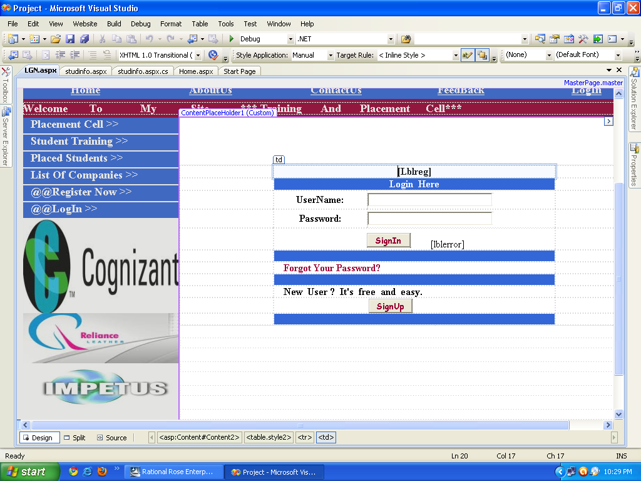

Registration Page

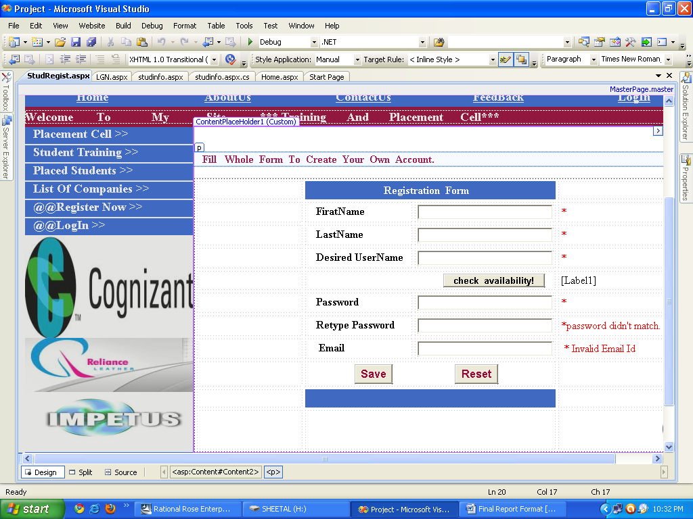

Company Details Page

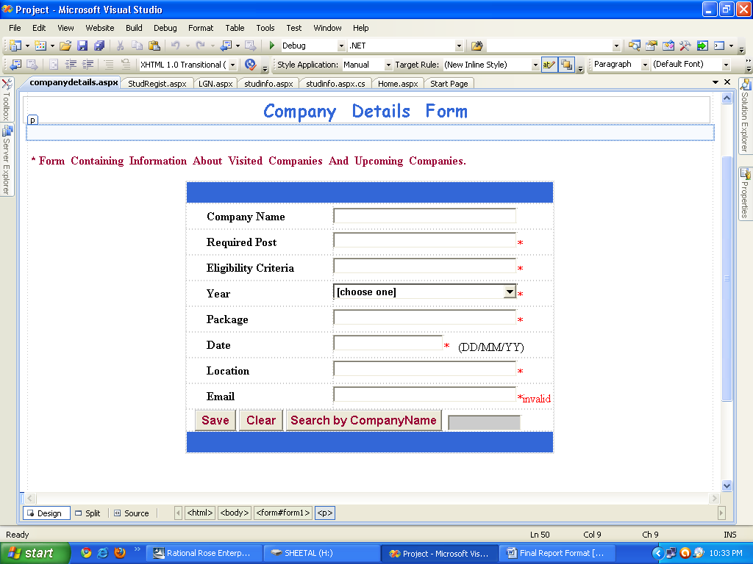

Allumni Details Page

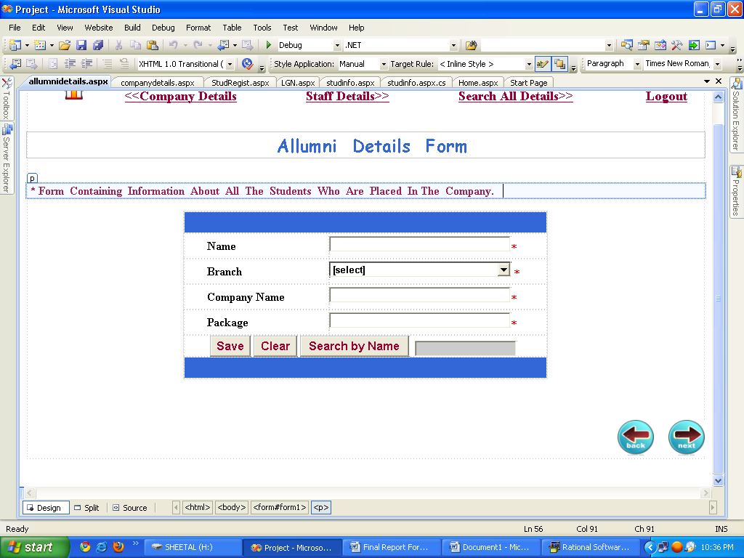

Placement Staff Details Page

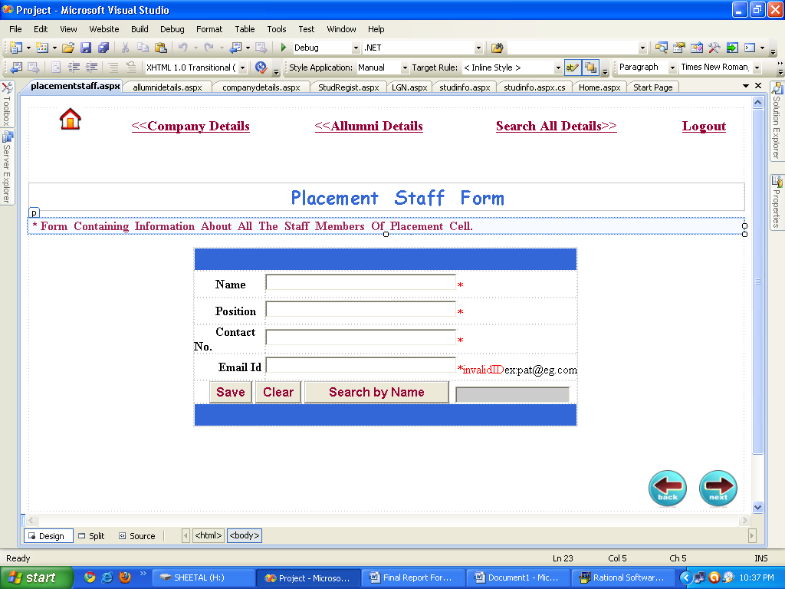

Search Student According to Aggregate And Produce Sorted List .

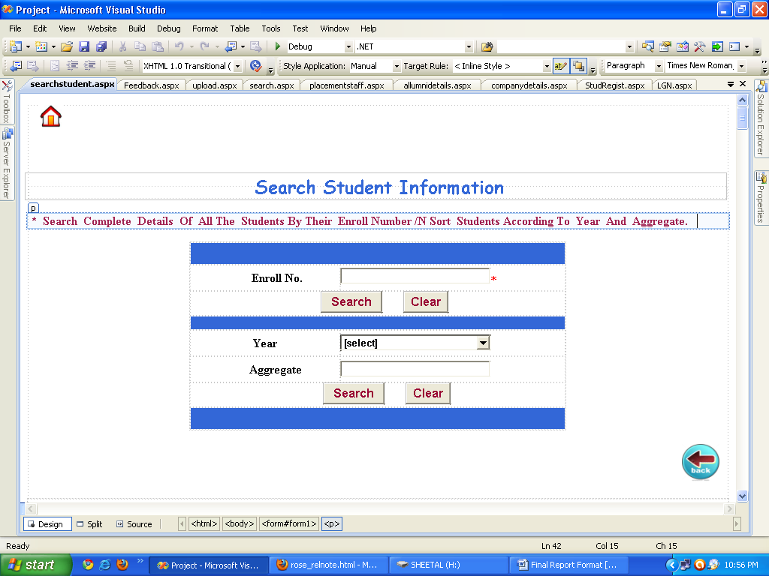

Student Details Page

- Personal Info

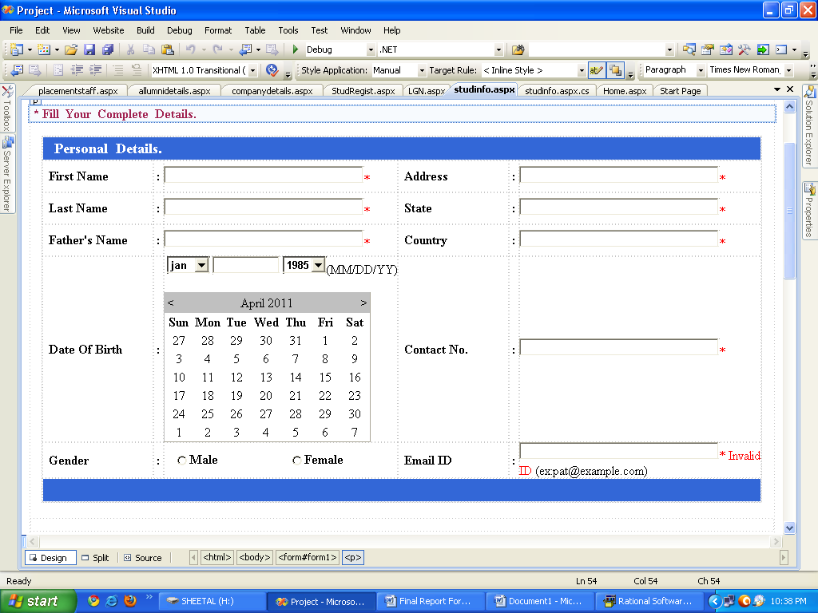

- Academic Info

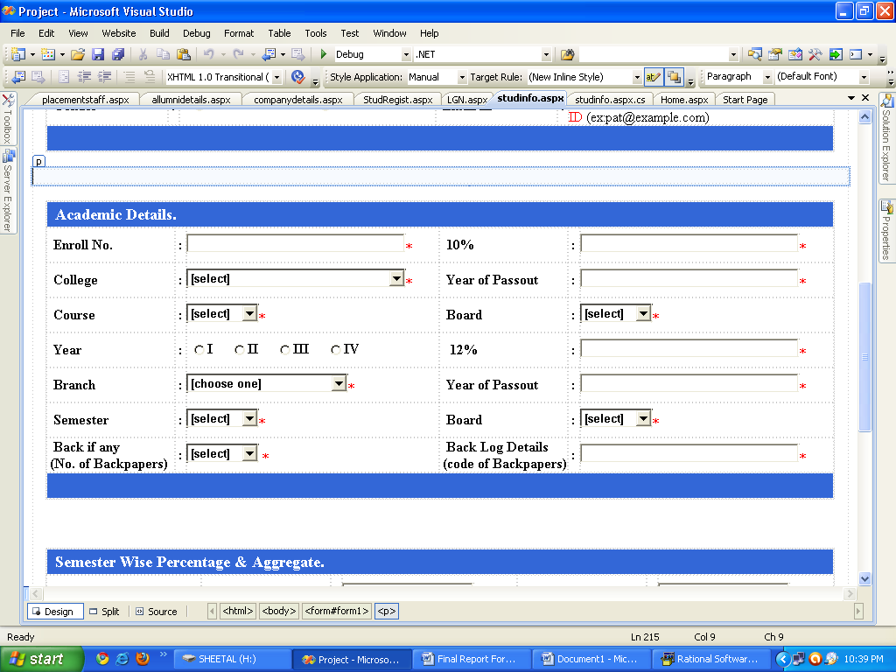

- Semester Wise Percentage & their Aggregate.

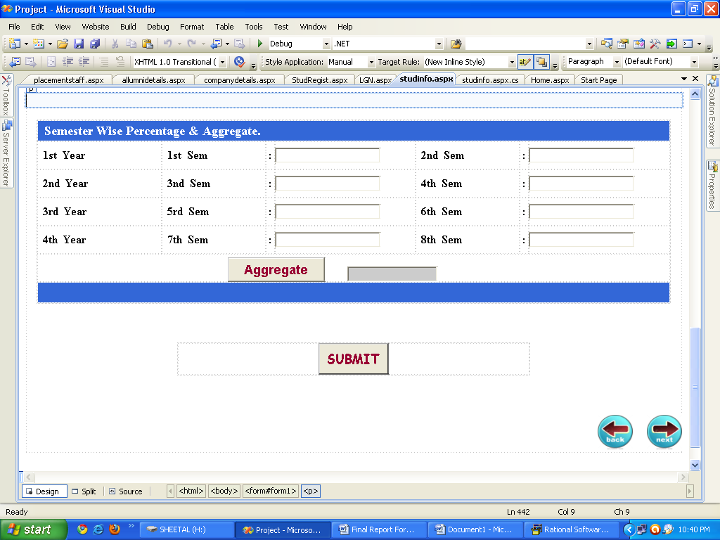

Upload/Download CV

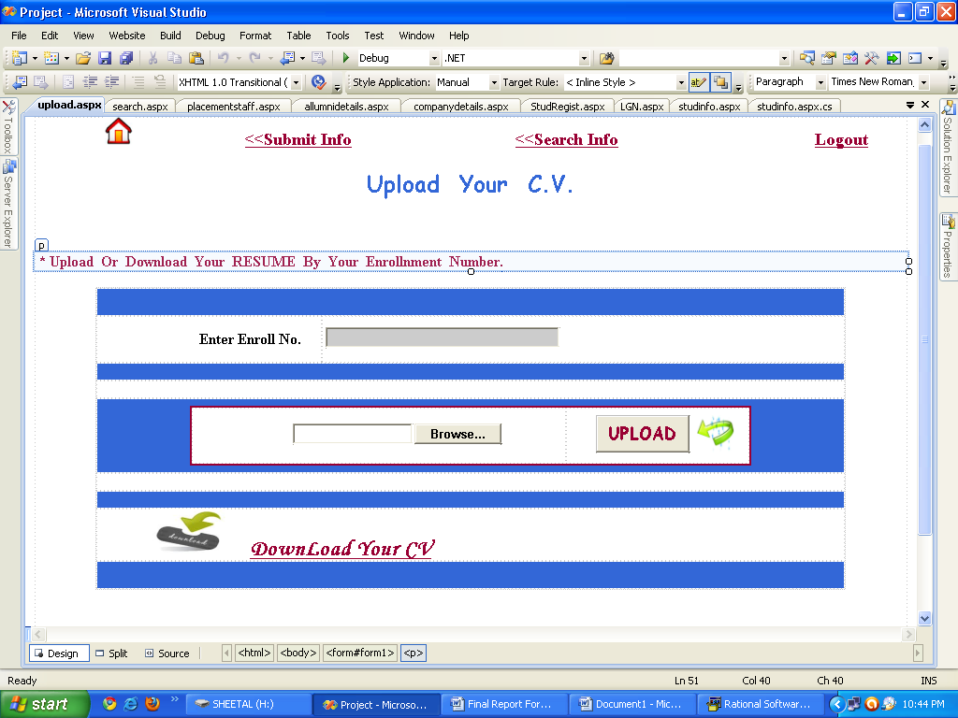

FeedBack Form

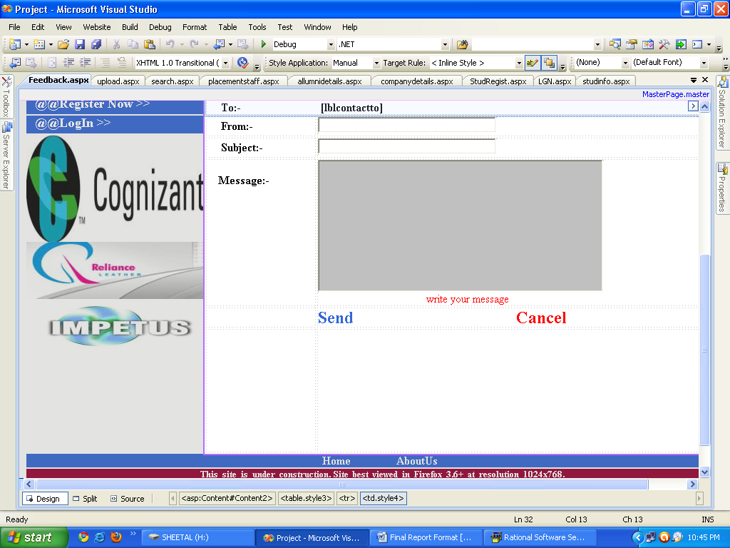

3.3.3 TESTING STRATEGIES ADOPTED:

TESTING:
Testing should be done through the implementation process. Even before and application is installed; it makes sense to verify that the basic platform is capable of achieving its design capabilities. System testing is a critical process. Testing is a process of executing a program with the explicit intention of finding errors that is making the program fail. This helps in finding the bottle neck in the system. Executing a program in a stimulated environment performs testing. The feedback from testing phase generally produces changes in the software to deal with errors and failures that are uncovered.

BLACK BOX TESTING:

In black box testing or functional testing test cases are decided. Test cases are decided on the basis of requirements or specifications of the program or module.
Black box testing is done in the project to remove errors:
- Incorrect or missing function
- Interface errors.
- Errors in data structure or external database access.
- Behavioral or performance error.
- Errors in initiation and termination.

WHITE BOX TESTING:

The White box testing or structural testing performs close operation of procedural details. They test the software logical path by having test cases exercising specific sets of condition and loops.
White box testing is done in the project to remove the errors:
- All modules path have been exercised at least once.
- Exercised on logical decisions.
- Executed all loops at their boundaries and within their operational bounds.
- Exercised internal data structure to ensure their validity.

INTEGRATION TESTING:
This testing is done to tackle problems of interface that is putting all interfaces together. When the separate modules are put together in an integrated manner, this testing is performed. This testing is systematic technique. This testing is performed to check the data should not be lost across an interface. The objective is to take an unit tested module and build a program structure that has been dedicated by design.

REGRESSION:
Regression was done to ensure proper working of each module with the whole system. Each module is embedded in the system and the whole tested for integrity.

3.3.4 SYSTEM TESTING:
System testing is done when the entire system has been fully integrated. The purpose of the system testing is to test how the different modules interact with each other and whether the system provides the functionality that was expected.

Software testing is an investigation conducted to provide stakeholders with information about the quality of the product or service under test. Software testing also provides an objective, independent view of the software to allow the business to appreciate and understand the risks of software implementation. Test techniques include, but are not limited to, the process of executing a program or application with the intent of finding software bugs (errors or other defects).
Software testing can also be stated as the process of validating and verifying that a software program/application/product:
- meets the business and technical requirements that guided its design and development;
- works as expected; and
- can be implemented with the same characteristics.

3.3.5 COMPONENT TESTING:

It focuses on verification efforts of the smallest grid of software designing that is a software component or module is tested. This testing is done at the coding phase. This testing uses procedural design as guide to test major control path and uncovers errors within the module boundary.

Following test were performed during component test:

- MODULE INTERFACE TEST: Module interface was tested to ensure information flow in and out of the program unit.

- LOCAL DATA STRUCTURE TESTING: Local data structure were tested to make surety that data store temporarily maintained their integrity during all steps in algorithm execution.

- BOUNDARY CONDITION TESTING: Boundary conditions were tested to make sure that the modules operate properly at boundaries.

- INDEPENDENT PATH TESTING: All independent paths through control structure were checked to make sure that all statements in a module has been executed.

- ERROR HANDLING PATH TEST: This is performed to handle exception.

4 CONCLUSION

4.1 BIBLIOGRAPHY:

Books:-
- Pro ASP.NET 3.5 in C# 2008.
- Pankaj Jalote, An Integrated Approach to Software Engineering, III edition.
- ASP.Net with C#(Black Book).
- Korth(DBMS).

Websites:-
- www.seminarproject.com
- www.dotnetspider.com
- www.w3schools.com
- www.Sourcecode.com

4.2 FUTURE EXTENSIONS:

- We can also send mail to all the students who are eligible for recruitment.
- The Admit card(hall ticket) can be provided on the website.
- We can show the overall results of students.
- Student can be notified about the TPO Announcements.
- Software Could be made available for all Departments.

